Q1)

*Recommendation*

My recommendation is to build a model in Excel Crystal Ball. By treating yearly profit as a nondeterministic normal distributed variable, we can use Crystal Ball to simulate the value of a customer. By doing so, we can quantitatively determine metrics of the customer which will allow Bank of Hanover to make more data based decisions.

*Managerial Definition of the Problem*

Bank of Hanover wants to measure the profitability of their customers, based on the fact that customers follow probabilistic factors. The expected of a customer is the following data table which follows a normal distribution N(mean profit, .25*mean profit). Additionally, each customer has a 20% chance they will cancel their credit card on any given year. If they do cancel, all subsequent future profits are also forfeit. The discount rate is 10% to calculate NPV.

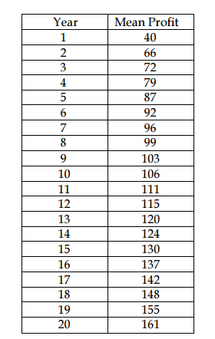

*Mathematical Model*

$$Expected NPV at Year 20= \sum_{t=1}^{20}{\frac{expected profits_{t}}{{\left(1+discount rate\right)}^{t}}}*retained_{t}$$

$$retained_{t}=if(AND\left(RAND()<0.8, retained_{t-1}=1\right), 1, 0)$$

*where retainedt = 1 if t =1 (first period is guaranteed)*

$Expected Profits=CB.Normal(mean profit,$*0.25* mean profit)*

*Solution*

1. Expected Value of NPV = 233.07

Standard Deviation of NPV = 191.41

The precision chart tells us that the expected NPV from a customer is within $1 of 95% confidence. The number of trials is 200,000.

1. 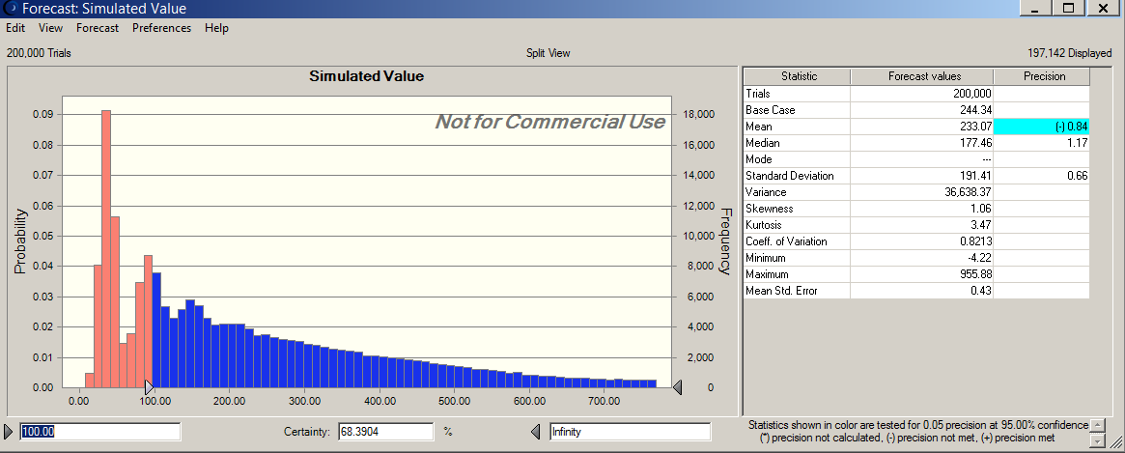68%, based on the Crystal Ball output below

Q2)

*Recommendation*

To value this real option, I recommend creating a stochastic model on Excel Crystal Ball. Because the value of an option is the difference between the expected NPV with the option and without the option, the model can simulate scenarios to find an expected value for both components of this equation.

*Managerial Definition of the Problem*

Garcia wants to price the value of a real option. In this option, Garcia can choose to decide in year 6 whether to continue its business or go out of business (cut cash flow in years 7-10). Their products sell at $100, and will grow each subsequent year by a normal distribution with mean 5% and standard deviation 3%. Initial sales are forecasted at 5000 units, with 5% growth per year. Costs are forecasted at $75, and will grow at a rate of normal distribution with mean 10% and standard deviation 3%. The discount rate is 10%

*Mathematical Model*

$$Expected NPV at year T= \sum_{t=1}^{T}{\frac{expected profits_{t}}{{\left(1+discount rate\right)}^{t}}}*retained_{t}$$

$$Expected Profits_{t}=Expected Revenue_{t}-Expected Costs_{t}$$

$$Expected Revenue_{t}=Product Price_{t}*Annual Sales_{t}$$

$$Product Price_{t}=Product Price_{t-1}+CB.Normal(0.05*Product Price_{t-1},0.03*Product Price_{t-1})$$

*where Product Pricet = 100 when t = 1*

$$Annual Sales_{t}=Annual Sales_{t-1}*1.05$$

*Where Annual Salest = 5000 when t = 1*

$$Expected Costs_{t}=Cost per Unit_{t}*Annual Sales_{t}$$

$$Cost per Unit_{t}= Cost per Unit_{t-1}+CB.Normal\left(0.1*Cost per Unit_{t-1}, 0.03*Cost per Unit_{t-1}\right)$$

*Solution*

1. Expected NPV = $304,618.94

95% Confidence Interval of Expected NPV = (-$287,940, $911,966)

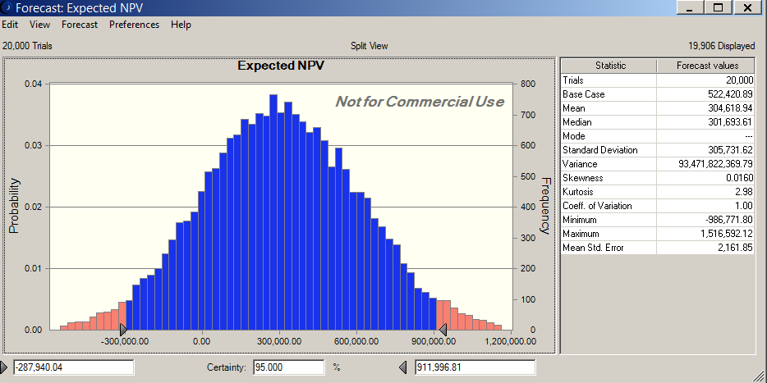

1. Expected NPV at Cutoff Rates:

$0 Expected NPV = $391,699

**$50,000 Expected NPV = $447,810**

$100,000 Expected NPV = $432,357

$150,000 Expected NPV = $424,558

Using the $50,000 cutoff seems to give the highest expected NPV. Seeing that the standard deviation is 178,442, a 95% interval (Mean+- 2 SDs) would land well within the range of the other Expected NPVs, so it would be difficult to say I am 95% confident that $50,000 is the best Expected NPV.

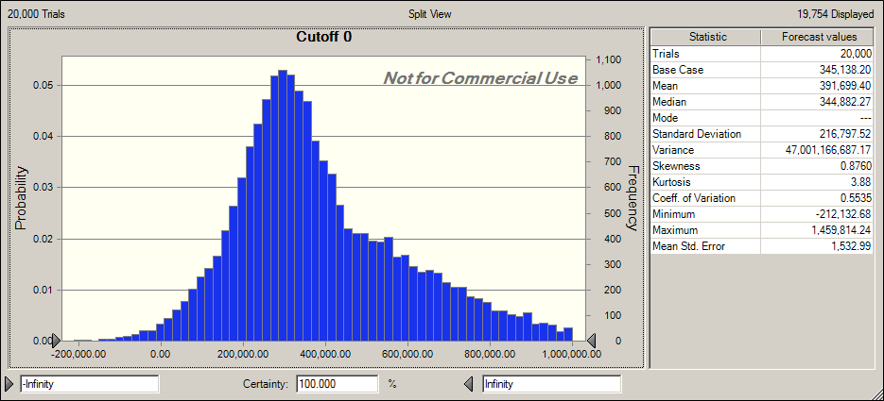

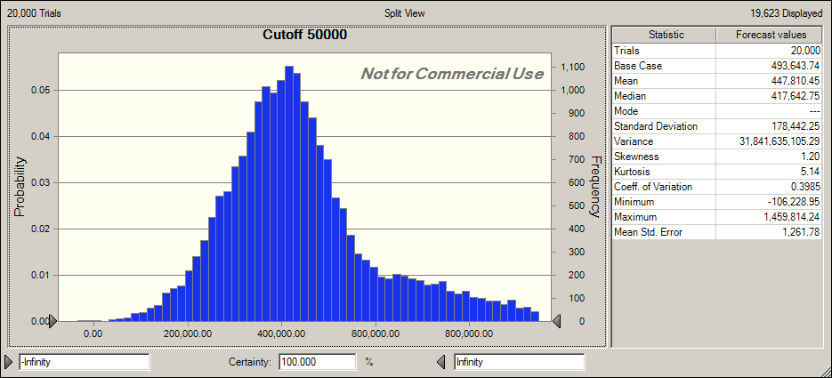

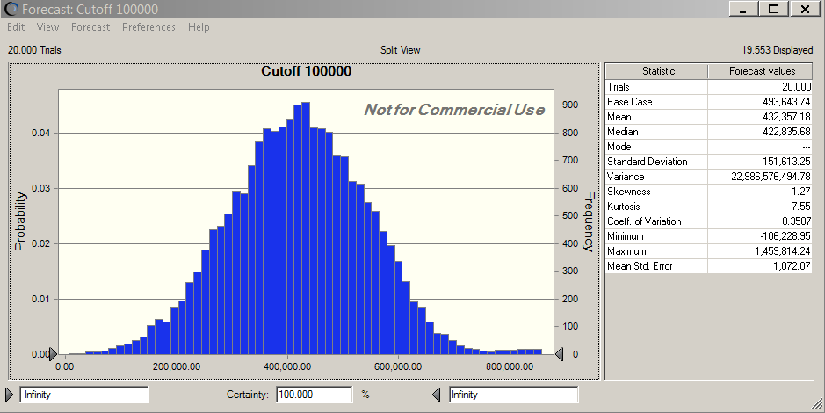

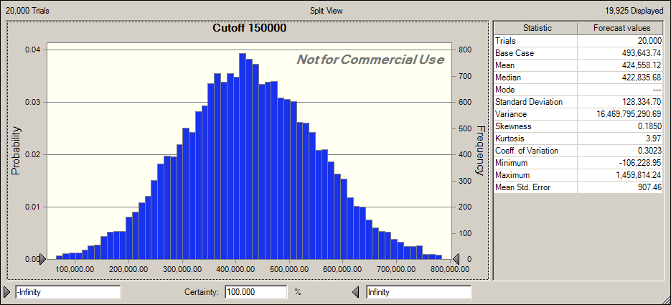

1. Using the $50,000 cutoff expected NPV calculated in part b, the difference is:

447,810 - 304,618 = $143,192, and thus is where the option should be valued at.